**EXP 1b**



clc;

close all;

clear all;

num = [1 3 2]

d1 = [1 4]

d2 = [1 4 7]

den = conv(d1,d2)

g = tf(num, den)

[z p k] = tf2zp (num, den)

pzmap(g)

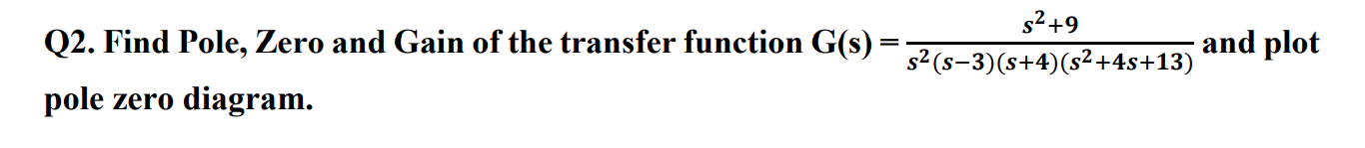

clc;

close all;

clear all;

num = [1 0 9]

d1 = [1]

d2 = [1 -3]

d3 = [1 4]

d4 = [1 4 13]

den1 = conv(d1,d2)

den2 = conv(den1,d3)

den3 = conv(den2,d4)

g = tf(num, den3)

[z p k] = tf2zp (num, den3)

pzmap(g)

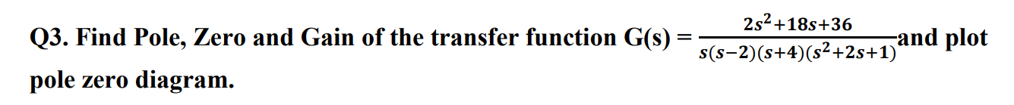

clc;

close all;

clear all;

num = [2 18 36]

d1 = [1 0]

d2 = [1 -2]

d3 = [1 4]

d4 = [1 2 1]

den1 = conv(d1,d2)

den2 = conv(den1,d3)

den3 = conv(den2,d4)

g = tf(num, den3)

[z p k] = tf2zp (num, den3)

pzmap(g)



clc;

close all;

clear all;

p = [-3, 2];

z = [-1];

k = 7;

[num,den] = zp2tf(z,p,k)

g = tf(num,den)

pzmap(g)

**EXP 2**

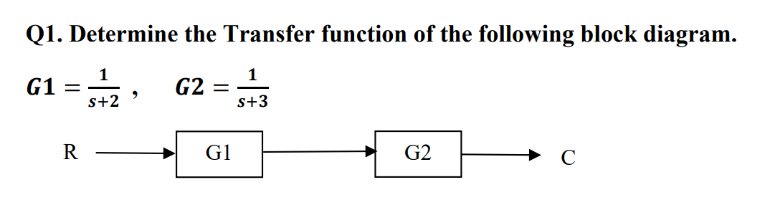

clc;

clear all;

close all;

G1 = tf([1],[1 2])

G2 = tf([1],[1 3])

m = series(G1,G2)

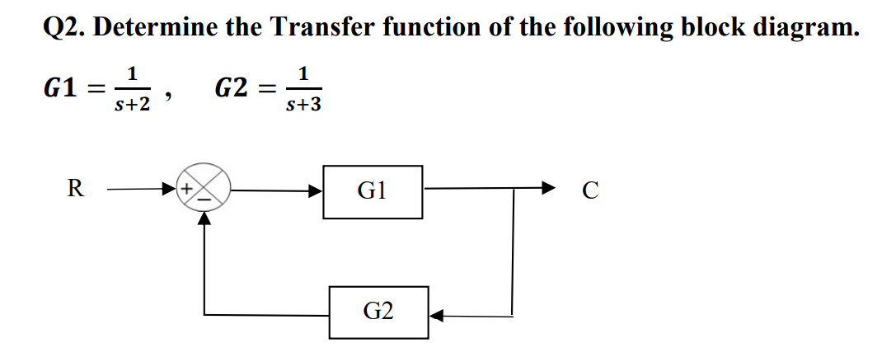

clc;

clear all;

close all;

G1 = tf([1],[1 2])

G2 = tf([1],[1 3])

m = feedback(G1,G2,-1)

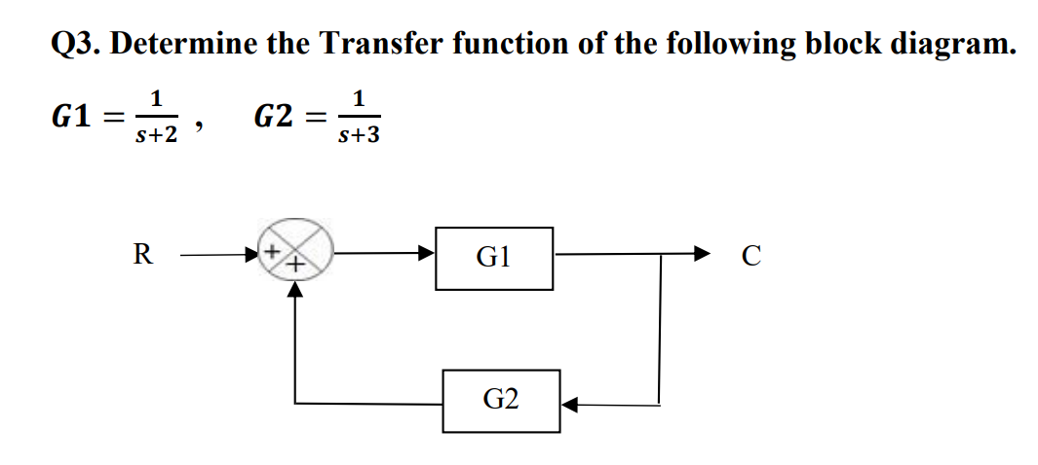

clc;

clear all;

close all;

G1 = tf([1],[1 2])

G2 = tf([1],[1 3])

m = feedback(G1,G2,1)

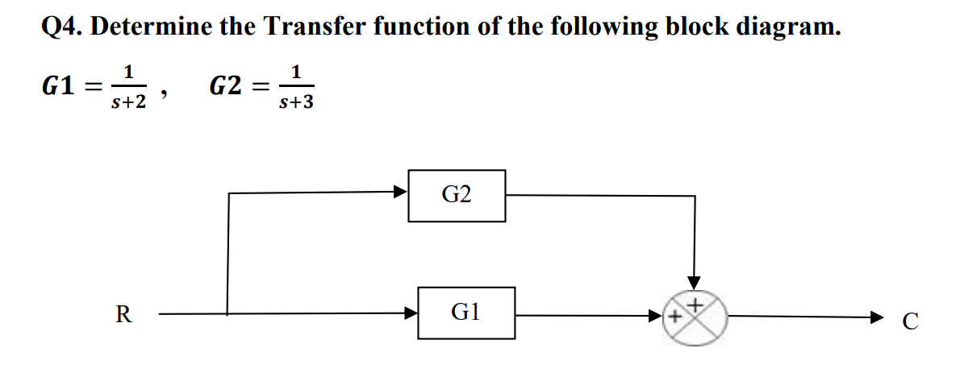

clc;

clear all;

close all;

G1 = tf([1],[1 2])

G2 = tf([1],[1 3])

m = parallel(G1,G2)

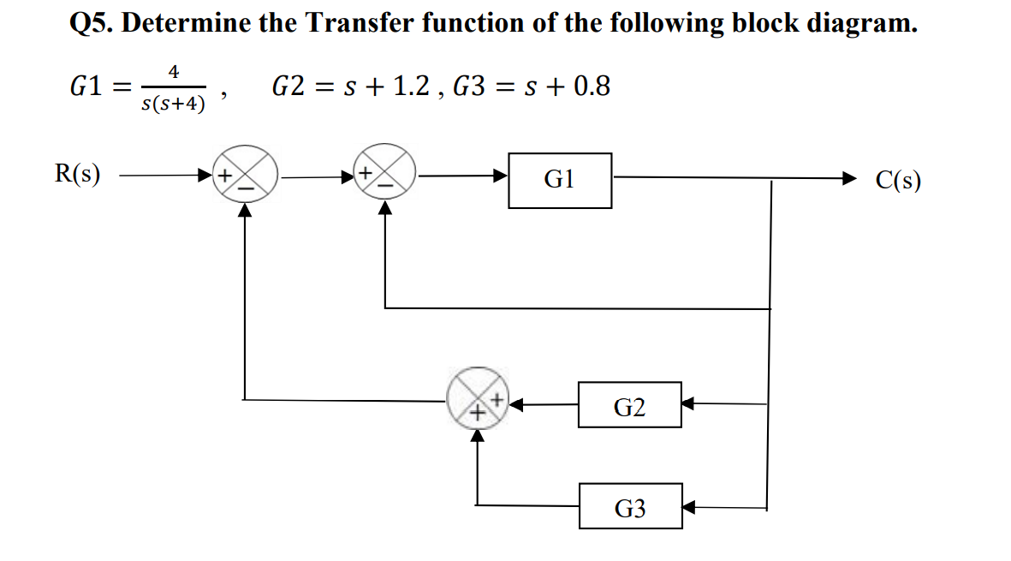

clc;

clear all;

close all;

G1 = tf([4],[1 4 0])

G2 = tf([1 1.2],[1])

G3 = tf([1 0.8],[1])

m = parallel(G2,G3)

n = feedback(G1,1,-1)

g = feedback(n,m,-1)

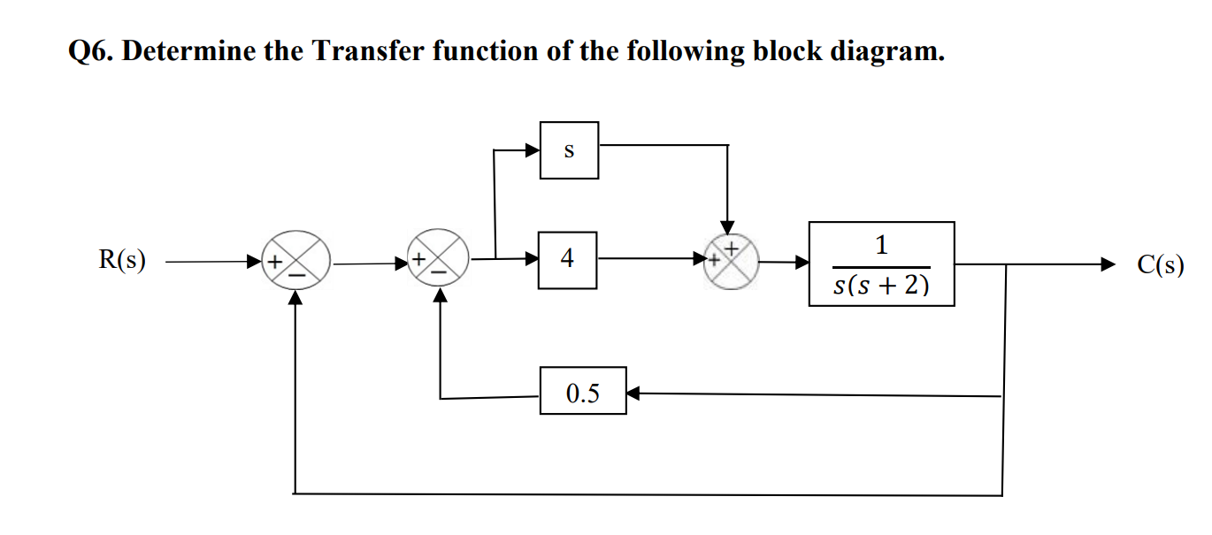

clc;

clear all;

close all;

G1 = tf([1 0], [1])

G2 = tf([4], [1])

G3 = tf([0.5], [1])

G4 = tf([1], [1 2 0])

m1 = parallel(G1,G2)

m2 = series(m1,G4)

m3 = feedback(m2,G3,-1)

g = feedback(m3,1,-1)

**EXP 3**

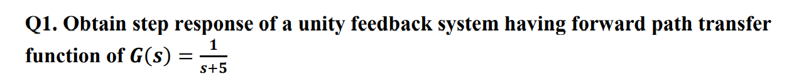

clc;

clear all;

close all;

n=[1]

d=[1 5]

g=tf(n,d)

f=feedback(g,1,-1)

step(f)

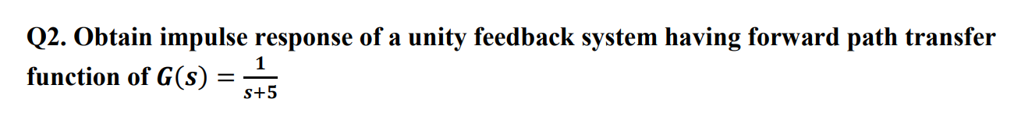

clc;

clear all;

close all;

n=[1]

d=[1 5]

g=tf(n,d)

f=feedback(g,1,-1)

impulse(f,'g')

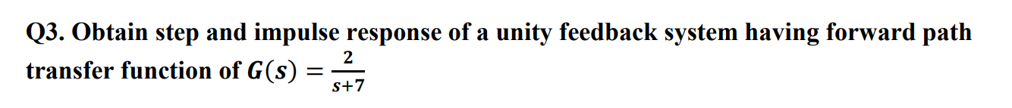

clc;

clear all;

close all;

n=[2]

d=[1 7]

g=tf(n,d)

f=feedback(g,1,-1)

subplot(1,2,1)

step(f)

subplot(1,2,2)

impulse(f,'g')

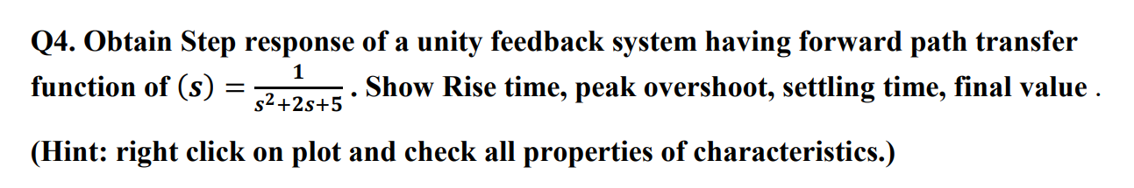

clc;

clear all;

close all;

n=[1]

d=[1 2 5]

g=tf(n,d)

f=feedback(g,1,-1)

step(f)

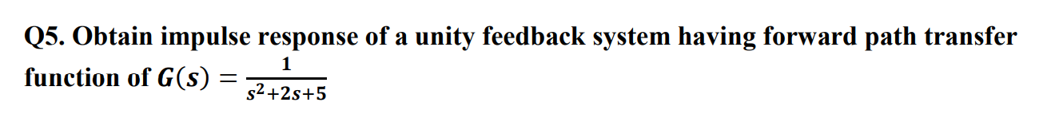

clc;

clear all;

close all;

n=[1]

d=[1 2 5]

g=tf(n,d)

f=feedback(g,1,-1)

impulse(f,'g')

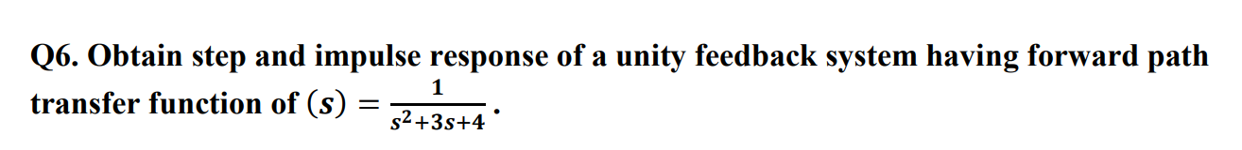

clc;

clear all;

close all;

n=[1]

d=[1 3 4]

g=tf(n,d)

f=feedback(g,1,-1)

subplot(1,2,1)

step(f)

subplot(1,2,2)

impulse(f,'g')

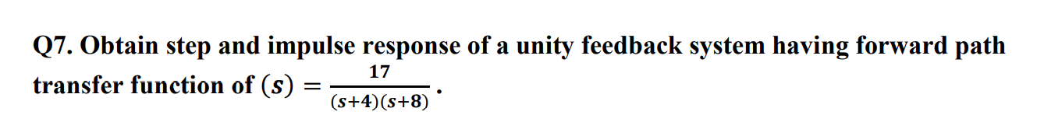

clc;

clear all;

close all;

n=[17]

d1=[1 4]

d2=[1 8]

d = conv(d1, d2)

g=tf(n,d)

f=feedback(g,1,-1)

subplot(1,2,1)

step(f)

subplot(1,2,2)

impulse(f,'g')

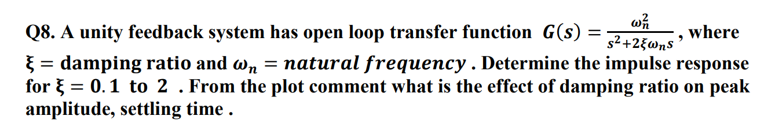

clc;

clear all;

close all;

w = 5;

e1 = 0.1;

e2 = 0.4;

e3 = 0.7;

e4 = 1.0;

e5 = 1.3;

e6 = 1.6;

e7 = 1.9;

n = [w*w]

d1 = [1 2*e1*w 0]

g1 = tf(n,d1)

f1 = feedback(g1, 1, -1)

subplot(3,3,1)

impulse(f1,'b')

d2 = [1 2*e2*w 0]

g2 = tf(n,d2)

f2 = feedback(g2, 1, -1)

subplot(3,3,2)

impulse(f2,'g')

d3 = [1 2*e3*w 0]

g3 = tf(n,d3)

f3 = feedback(g3, 1, -1)

subplot(3,3,3)

impulse(f3,'r')

d4 = [1 2*e4*w 0]

g4 = tf(n,d4)

f4 = feedback(g4, 1, -1)

subplot(3,3,4)

impulse(f4,'c')

d5 = [1 2*e5*w 0]

g5 = tf(n,d5)

f5 = feedback(g5, 1, -1)

subplot(3,3,5)

impulse(f5,'m')

d6 = [1 2*e6*w 0]

g6 = tf(n,d6)

f6 = feedback(g6, 1, -1)

subplot(3,3,6)

impulse(f6,'y')

d7 = [1 2*e7*w 0]

g7 = tf(n,d7)

f7 = feedback(g7, 1, -1)

subplot(3,3,7)

impulse(f7,'k')

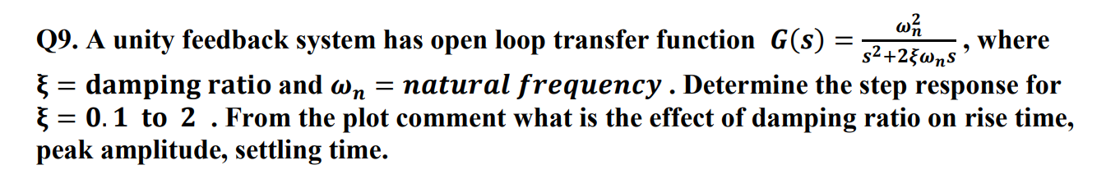

clc;

clear all;

close all;

w = 5;

e1 = 0.1;

e2 = 0.4;

e3 = 0.7;

e4 = 1.0;

e5 = 1.3;

e6 = 1.6;

e7 = 1.9;

n = [w*w]

d1 = [1 2*e1*w 0]

g1 = tf(n,d1)

f1 = feedback(g1, 1, -1)

subplot(3,3,1)

step(f1,'b')

d2 = [1 2*e2*w 0]

g2 = tf(n,d2)

f2 = feedback(g2, 1, -1)

subplot(3,3,2)

step(f2,'g')

d3 = [1 2*e3*w 0]

g3 = tf(n,d3)

f3 = feedback(g3, 1, -1)

subplot(3,3,3)

step(f3,'r')

d4 = [1 2*e4*w 0]

g4 = tf(n,d4)

f4 = feedback(g4, 1, -1)

subplot(3,3,4)

step(f4,'c')

d5 = [1 2*e5*w 0]

g5 = tf(n,d5)

f5 = feedback(g5, 1, -1)

subplot(3,3,5)

step(f5,'m')

d6 = [1 2*e6*w 0]

g6 = tf(n,d6)

f6 = feedback(g6, 1, -1)

subplot(3,3,6)

step(f6,'y')

d7 = [1 2*e7*w 0]

g7 = tf(n,d7)

f7 = feedback(g7, 1, -1)

subplot(3,3,7)

step(f7,'k')

**EXP 4**

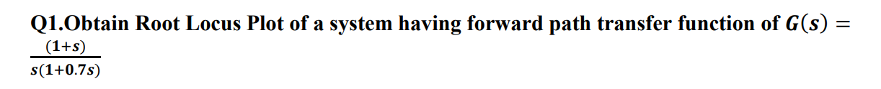

clc;

clear all;

close all;

n = [1 1]

d1 = [1 0]

d2 = [0.7 1]

d = conv(d1, d2)

g = tf(n,d)

rlocus(g)

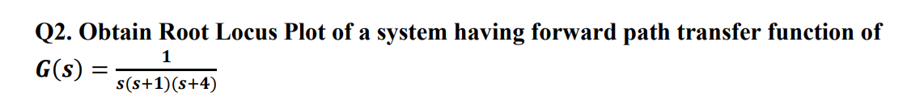

clc;

clear all;

close all;

n = [1]

d1 = [1 0]

d2 = [1 1]

d3 = [1 4]

d4 = conv(d1,d2)

d = conv(d3,d4)

g = tf(n,d)

rlocus(g)

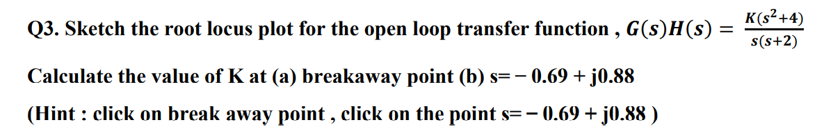

clc;

clear all;

close all;

num=[1 0 4]

den=[1 2 0]

g=tf(num,den)

rlocus(num,den)

rlocfind(num,den)



clc;

clear all;

close all;

n = [1 2]

d = [1 2 2]

g = tf(n,d)

rlocus(g)

rlocfind(n,d)



clc;

clear all;

close all;

n = [1]

d1 = [1 0]

d2= [1 2 2]

d= conv(d1,d2)

g = tf(n,d)

rlocus(g)

rlocfind(n,d)

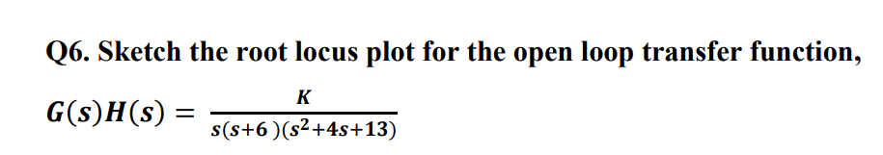

clc;

clear all;

close all;

n = [1]

d1 = [1 0]

d2= [1 6]

d3=[1 4 13]

d4= conv(d1,d2)

d = conv(d3,d4)

g = tf(n,d)

rlocus(g)

rlocfind(n,d)

**EXP 5**

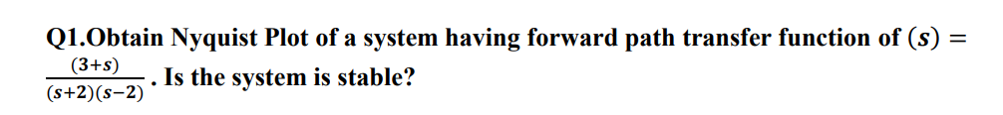

clc;

clear all;

close all;

n = [1 3]

d1 = [1 2]

d2 = [1 -2]

d = conv(d1, d2)

g = tf(n,d)

nyquist(g)

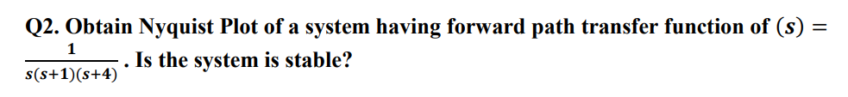

clc;

clear all;

close all;

n = [1]

d1 = [1 0]

d2 = [1 1]

d3 = [1 4]

d4 = conv(d1, d2)

d = conv(d3,d4)

g = tf(n,d)

nyquist(g)

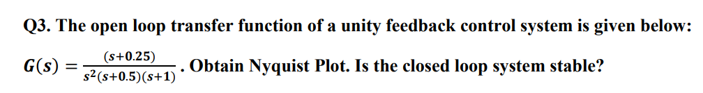

clc;

clear all;

close all;

n = [1 0.25]

d1 = [1 0 0]

d2 = [1 0.5]

d3 = [1 1]

d4 = conv(d1, d2)

d = conv(d3,d4)

g = tf(n,d)

nyquist(g)

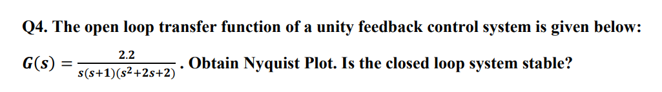

clc;

clear all;

close all;

n = [2.2]

d1 = [1 0]

d2 = [1 1]

d3 = [1 2 2]

d4 = conv(d1, d2)

d = conv(d3,d4)

g = tf(n,d)

nyquist(g)

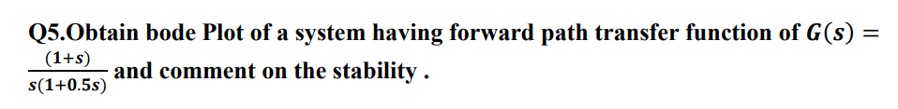

clc;

clear all;

close all;

n = [1 1]

%d1 = [0.5 1]

%d2 = [1 0]

%d = conv(d1,d2)

d = [0.5 1 0]

g = tf(n,d)

bode(g)

margin(g)

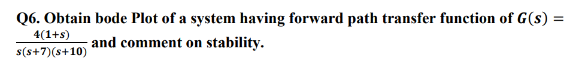

clc;

clear all;

close all;

n = [4 4]

d1 = [1 0]

d2 = [1 7]

d3 = [1 10]

d4 = conv(d1,d2)

d = conv(d3, d4)

g = tf(n,d)

bode(g)

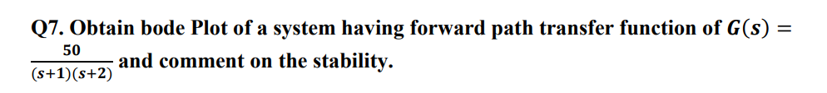

clc;

clear all;

close all;

n = [50]

d1 = [1 1]

d2 = [1 2]

d = conv(d1, d2)

g = tf(n,d)

bode(g)

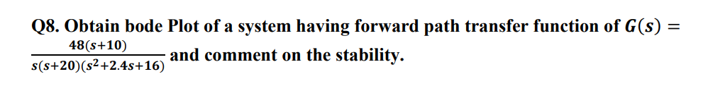

clc;

clear all;

close all;

n = [48 480]

d1 = [1 0]

d2 = [1 20]

d3 = [1 2.4 16]

d4 = conv(d1,d2)

d = conv(d3, d4)

g = tf(n,d)

bode(g)

**EXP 6**

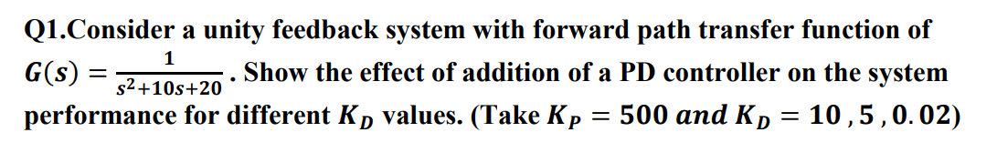

clc;

clear all;

close all;

num = [1]

den = [1 10 20]

g = tf(num,den)

t_f = feedback(g,1,-1)

step(t_f,'y')

hold on

kp1 = 10

num1 = [kp1]

den1 = [1 10 20]

g1 = tf(num1,den1)

tf1 = feedback(g1,1,-1)

step(tf1,'m')

hold on

kp = 500

kd1 = 10

num2 = [kd1 kp]

den2 = [1 10 20]

g2 = tf(num2,den2)

tf2 = feedback(g2,1,-1)

step(tf2,'b')

hold on

kd2 = 5

num3 = [kd2 kp]

den3 = [1 10 20]

g3 = tf(num3, den3)

tf3 = feedback(g3,1,-1)

step(tf3,'r')

hold on

kd3 = 0.02

num4 = [kd3 kp]

den4 = [1 10 20]

g4 = tf(num4, den4)

tf4 = feedback(g4,1,-1)

step(tf4,'g')

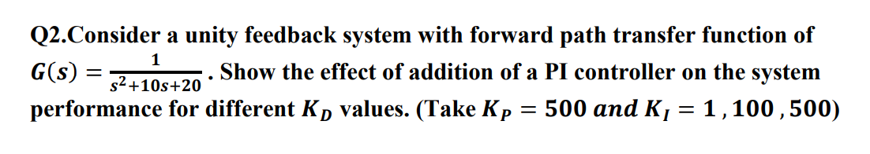

clc;

clear all;

close all;

num = [1]

den = [1 10 20]

g = tf(num,den)

t_f = feedback(g,1,-1)

step(t_f,'y')

hold on

kp1 = 10

num1 = [kp1]

den1 = [1 10 20]

g1 = tf(num1,den1)

tf1 = feedback(g1,1,-1)

step(tf1,'m')

hold on

kp = 500

ki1 = 1

num2 = [kp ki1]

d = [1 0] %due to integrator, order and type increased

den2 = conv(d,den)

g2 = tf(num2,den2)

tf2 = feedback(g2,1,-1)

step(tf2,'b')

hold on

ki2 = 100

num3 = [kp ki2]

den3 = conv(d,den)

g3 = tf(num3, den3)

tf3 = feedback(g3,1,-1)

step(tf3,'r')

hold on

ki3 = 500

num4 = [kp ki3]

den4 = conv(d,den)

g4 = tf(num4, den4)

tf4 = feedback(g4,1,-1)

step(tf4,'g')

hold on

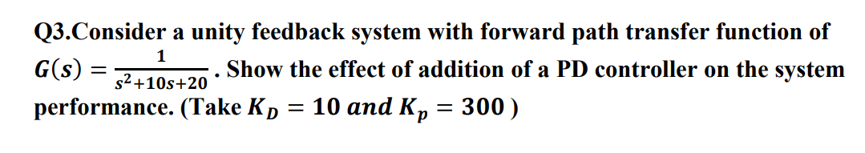

clc;

clear all;

close all;

num = [1]

den = [1 10 20]

g = tf(num,den)

t_f = feedback(g,1,-1)

step(t_f,'y')

hold on

kp1 = 10

num1 = [kp1]

den1 = [1 10 20]

g1 = tf(num1,den1)

tf1 = feedback(g1,1,-1)

step(tf1,'m')

hold on

kp = 300

kd1 = 10

num2 = [kd1 kp]

den2 = [1 10 20]

g2 = tf(num2,den2)

tf2 = feedback(g2,1,-1)

step(tf2,'b')

hold on

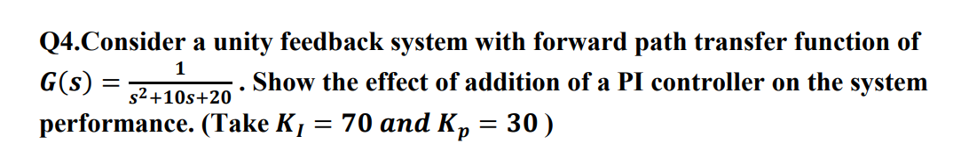

clc;

clear all;

close all;

num = [1]

den = [1 10 20]

g = tf(num,den)

t_f = feedback(g,1,-1)

step(t_f,'y')

hold on

kp1 = 10

num1 = [kp1]

den1 = [1 10 20]

g1 = tf(num1,den1)

tf1 = feedback(g1,1,-1)

step(tf1,'m')

hold on

kp = 30

ki = 70

num2 = [kp ki]

d = [1 0] %due to integrator, order and type increased

den2 = conv(d,den)

g2 = tf(num2,den2)

tf2 = feedback(g2,1,-1)

step(tf2,'b')

hold on

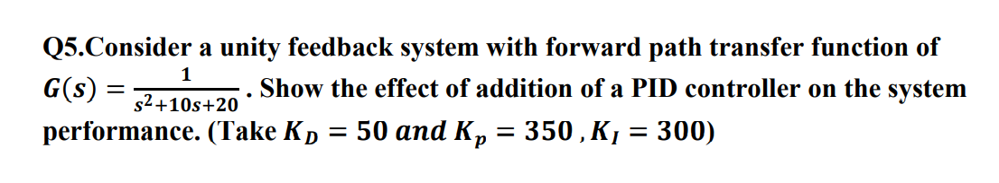

clc;

clear all;

close all;

num = [1]

den = [1 10 20]

g = tf(num,den)

t_f = feedback(g,1,-1)

step(t_f,'y')

hold on

kp1 = 10

num1 = [kp1]

den1 = [1 10 20]

g1 = tf(num1,den1)

tf1 = feedback(g1,1,-1)

step(tf1,'m')

hold on

kd = 50

kp = 350

ki = 300

num2 = [kd kp ki]

d = [1 0]

den2 = conv(d,den)

g2 = tf(num2,den2)

tf2 = feedback(g2,1,-1)

step(tf2,'b')

hold on